BrownEAR Setup Notes

Introduction

This document describes the various artifacts that are required to run the BrownEAR application.
BrownEAR is a JEE application that contains one MDB (message driven bean) EJB that reads a message from a request queue and then writes the same message (with “Hello” as a prefix) to a response queue.

MQ Artifacts

Queue Manager

This is a standard QM definition.
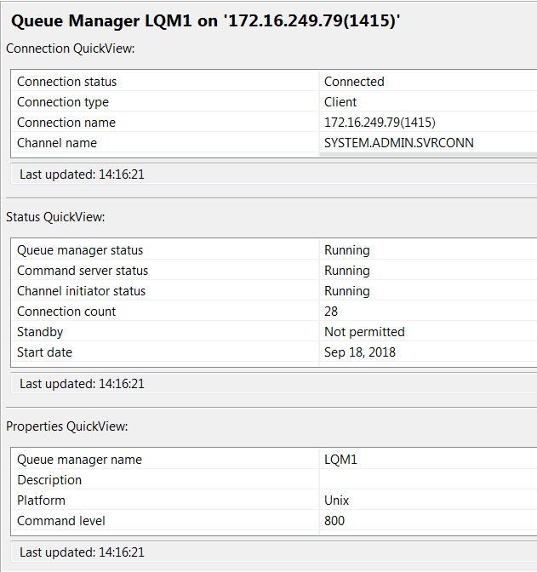

Queues

There are two queues required, a request queue and a response queue.

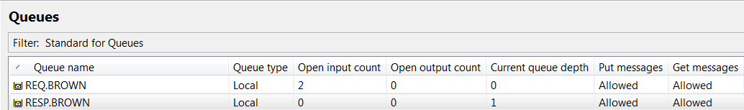
One server connection channel (CLOUD.APP.SVRCONN) was defined for the MDB to exclusively use to connect to the queue manager.

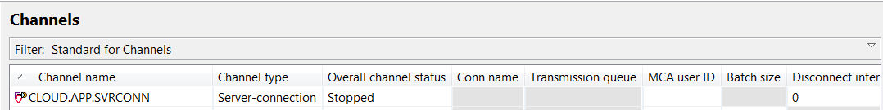

For the CLOUD.APP.SVRCONN channel, the MCA user ID was set to admin. This means that the MDB application will be connected to the Queue Manager as “admin” which is a user ID defined on the operating system where the Queue Manager is running.

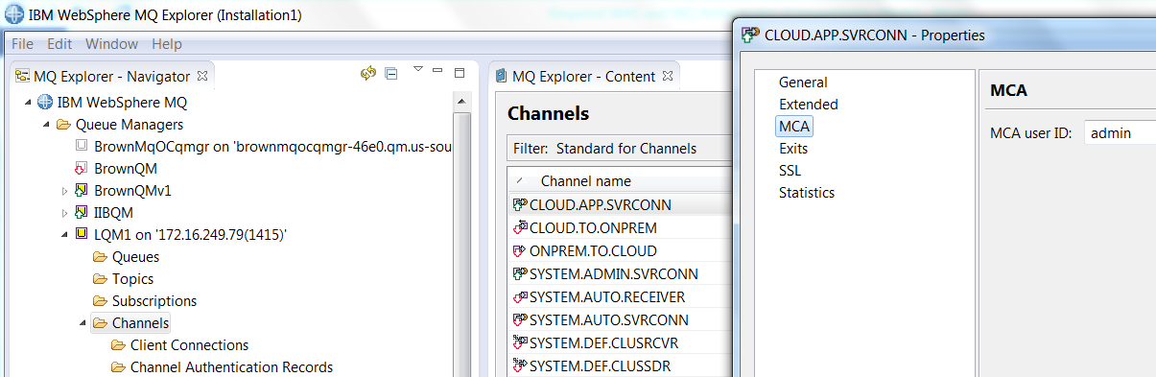

Channel Authentication Record

One channel authentication record was added to the CLOUD.APP.SVRCONN to not block users.
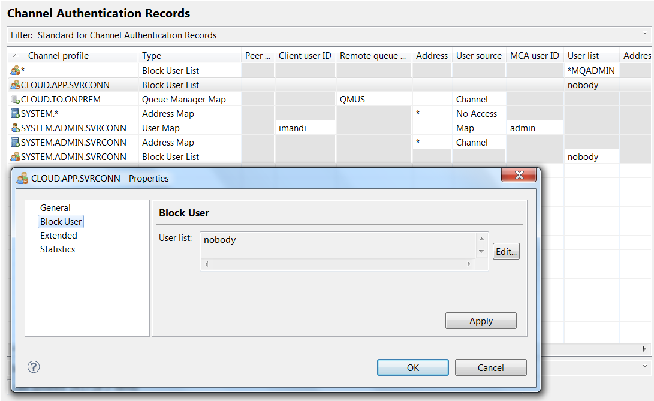

Listener

One listener was defined with port 1415 for the MDB application to connect into.
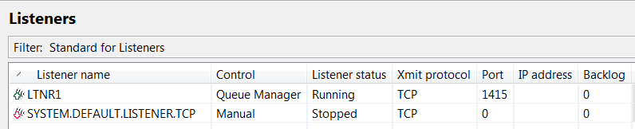

Runmqsc Commands

These commands were issued with the “runmqsc” CLI to allow clients to connect.
SET CHLAUTH(CLOUD.APP.SVRCONN) TYPE(BLOCKUSER) USERLIST('nobody')
ALTER AUTHINFO(SYSTEM.DEFAULT.AUTHINFO.IDPWOS) AUTHTYPE(IDPWOS) CHCKCLNT(OPTIONAL)
REFRESH SECURITY TYPE(CONNAUTH)

WAS Artifacts

Queue Connection Factory

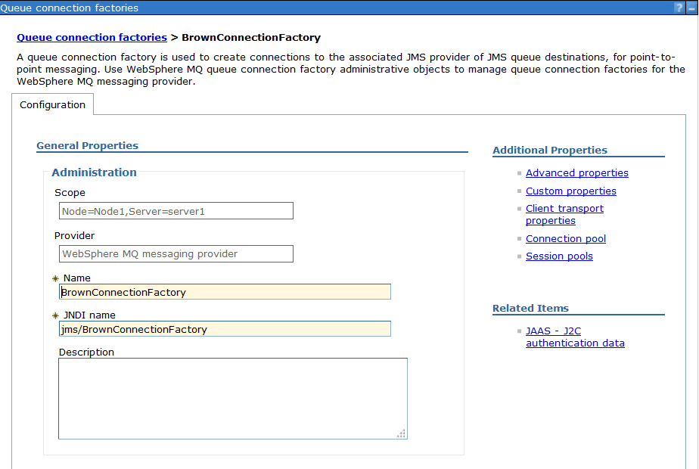
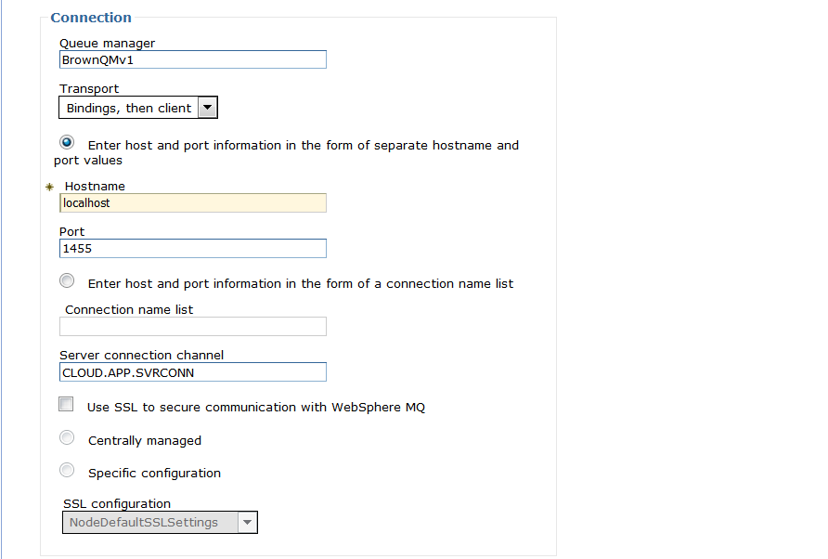
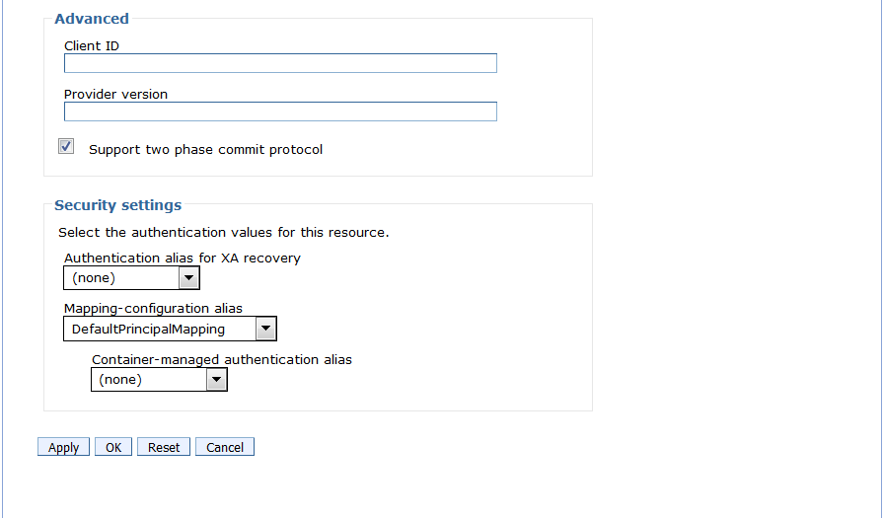

Queues

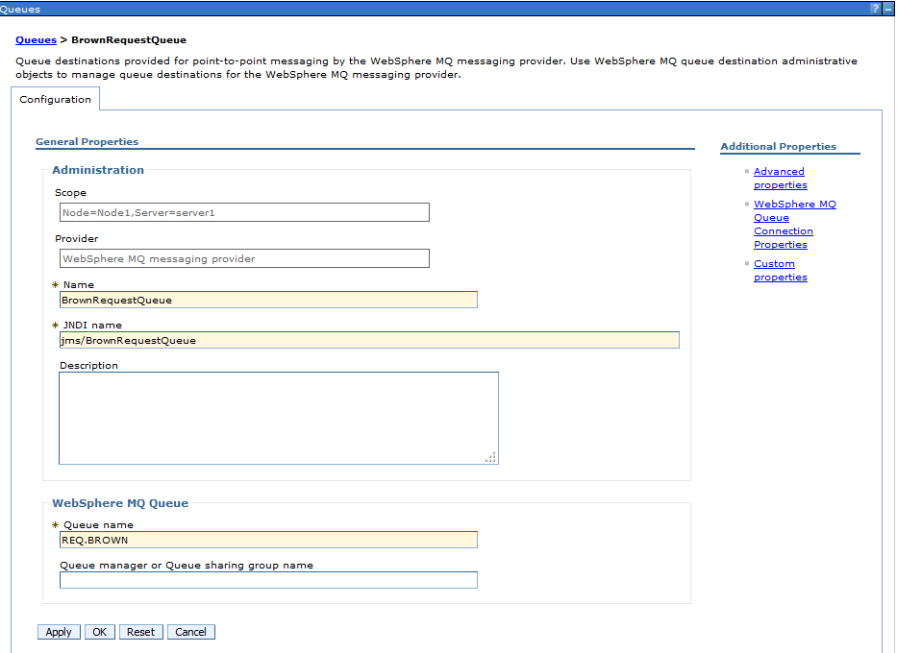

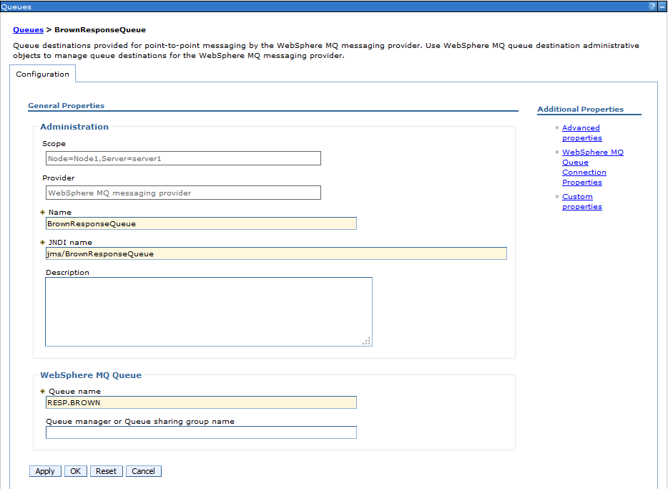

Activation Specification

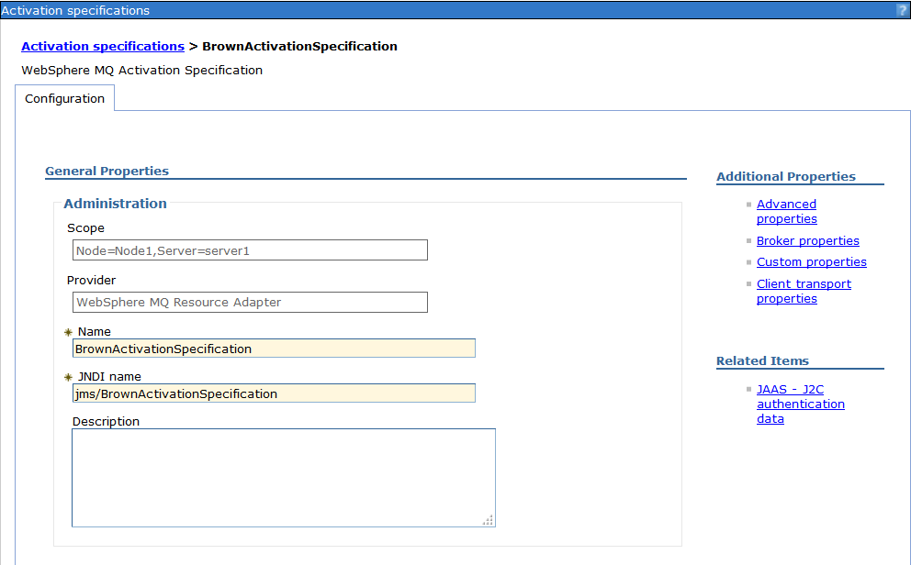

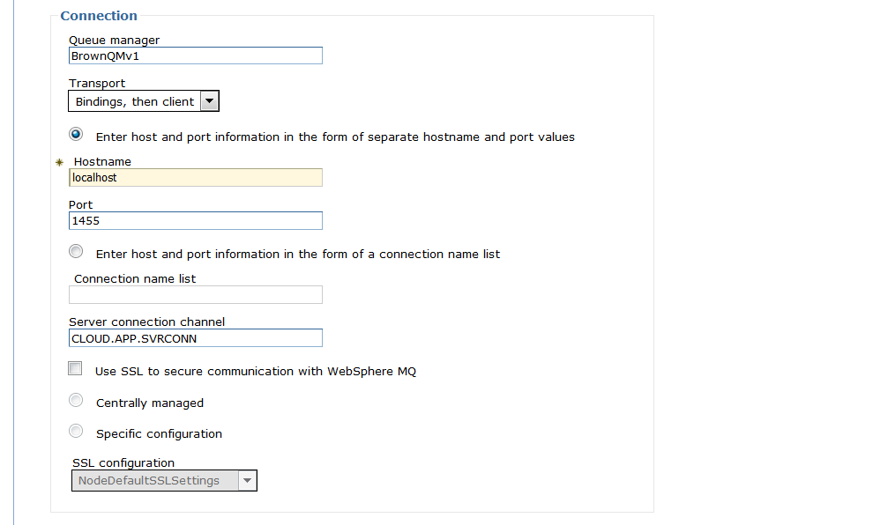

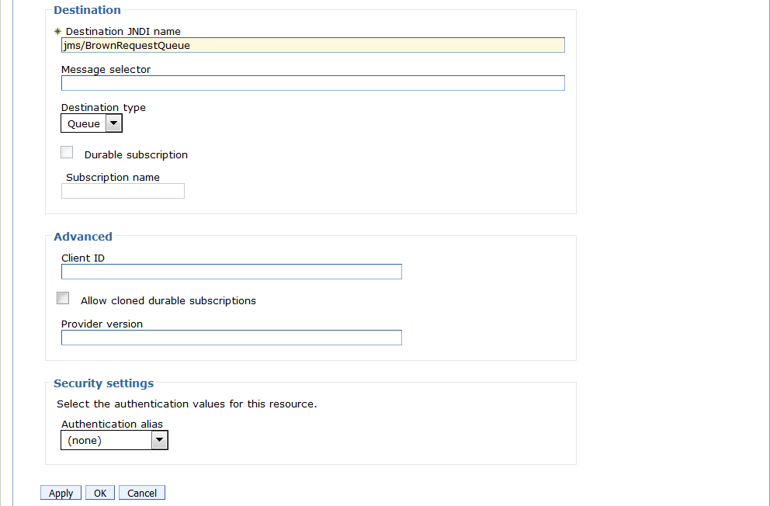

Authentication Alias

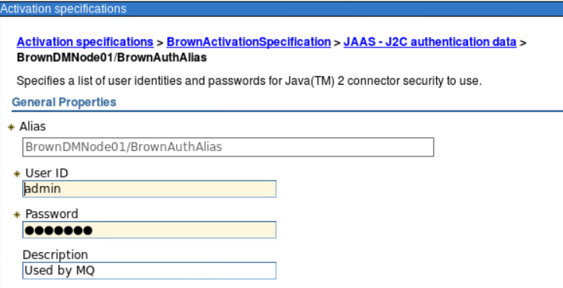

EAR Deployment

When you deploy the EAR, make sure the activation specification parameters are correct and match your artifact names.
